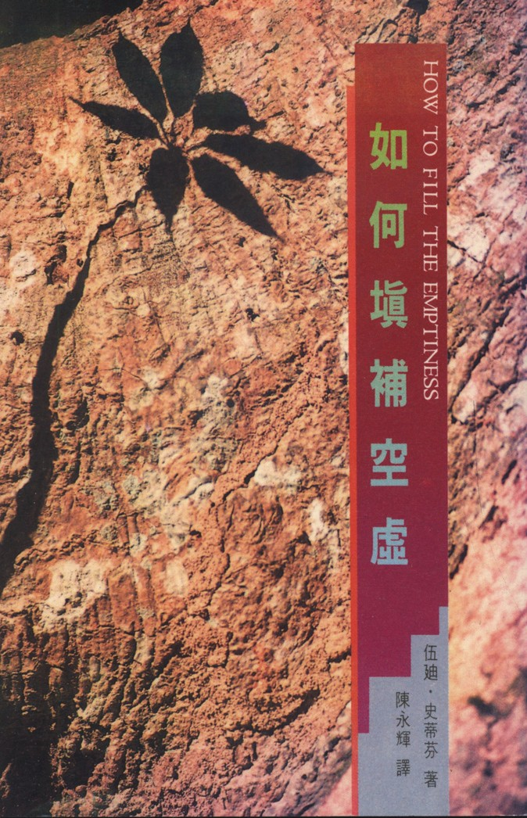

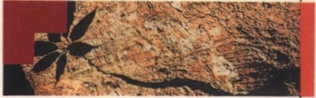
I
if
•
..

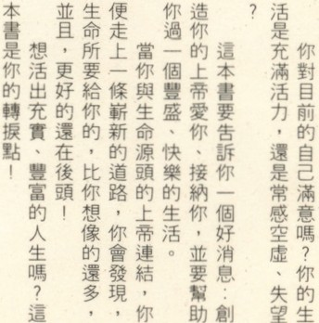"!'
0
N
"0'
0
'"
N
8
0
0
"'



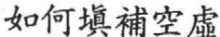

How To Fill The Emptiness

by Woodie J. Stevens

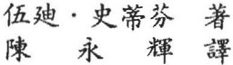

** A
.:lut1"1 -\;J][

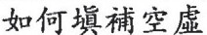i'F '/!i•: ffi9J!l· 'il:.'ii\'3}
'/t:i!)fij)(l'li!
'lt : £$A m w u
{4;!!1! : :l<::l'tl!H llll m! BflJ!Jlt U
a trtitz;lul\ 22 'llli 9 J
ill:iili: (02)5628133-5 {\1):!!'! : ( 02)5614743
!l!lli&J!Jm : o54355o-o 1":£. : : <::l't m
lfJHJ'A : i'Oi M
rri&!ltl'iillll"""" a *7998 !IIi
-:tL:tLO!f.liflWii& • lii'Ji'llllil!Eil£•Yl: •
How To Fill The Emptiness by Woodie J. Stevens
Translated by Chen, Yeong·Huei
Copyright © 1987 by Beacon Hill Press of Kan·
sas City
Distributed by Glory Press
P. 0. Box 3526 Taipei, Ta iwan, I 0099 R 0. C Tel:(02) 5628133.5
All Rights Reserved
May 1990 I st Edition
*;i±i*:fldt. !1!iilil¥ · =**l<!'f'T • lliHl-!iX llll
!!J'l' !Uitii!U' o i!l fll.l'l'51!!l • 'l':ffdt'Jl. o
CY!lM<llii!iX mlll\1; • oilf' >llll*; ±ll!!!l!l
:Ji::1l Wf'E;-48 7t

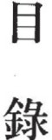1{Jt P3- 1{Jt
i1;1. RJ ·"·Jf. .Jii'ilt

{11!:1."-- lilt #:.t *
::f!

'>t I!] ft.] •
1t'!)r ,W..t;t: ;{-!!!
.I.d!l:or : 1*;t ;
,It : 'itt : f!l "'- :
if.. ; !1!1- : -t T ;
:. ?ill :. :.
. . .
. . .
-ir + :

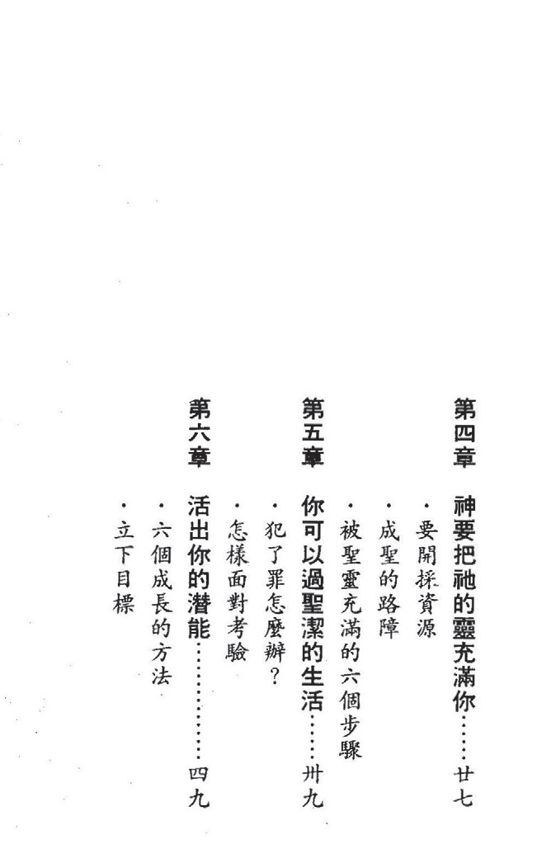

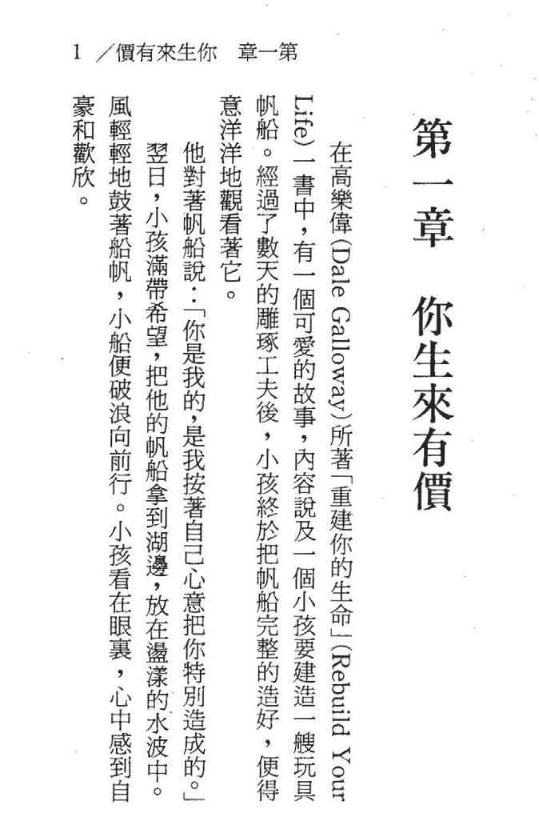

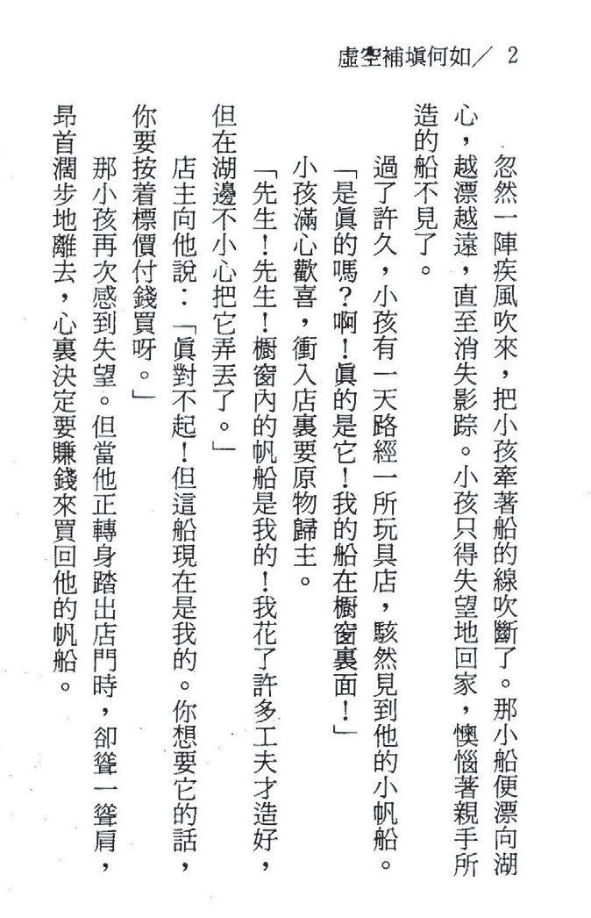

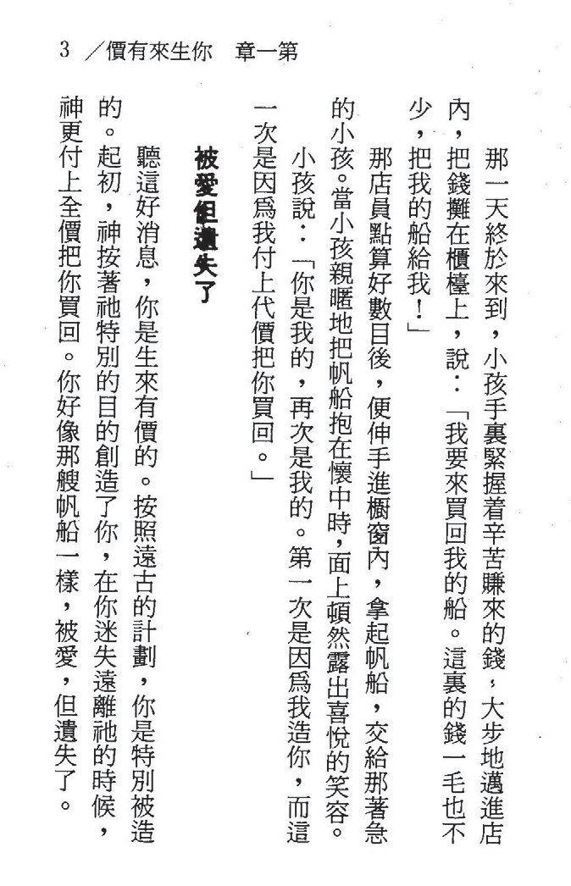

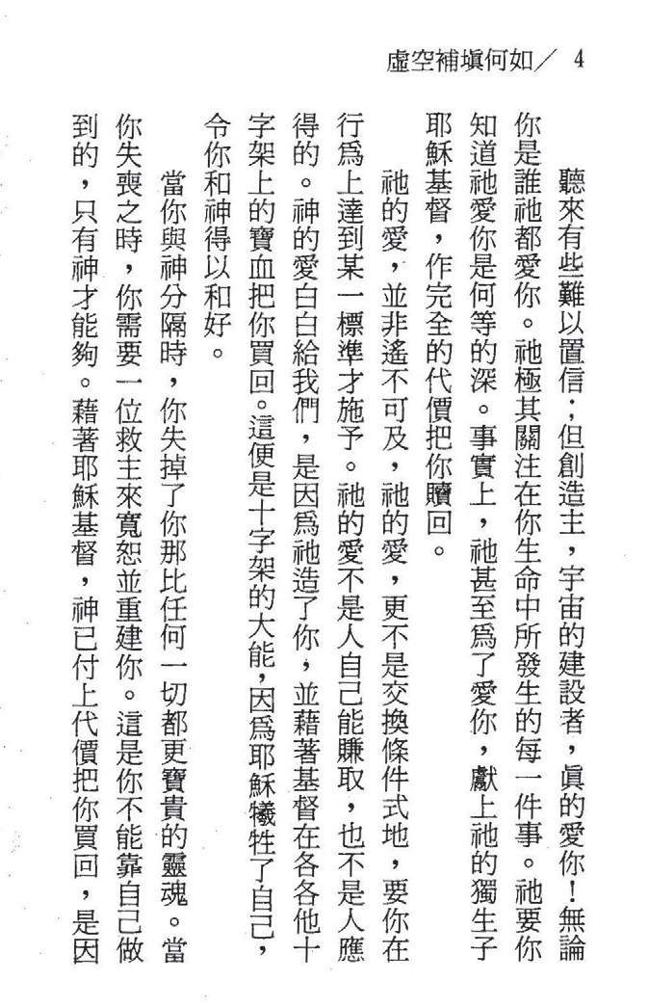

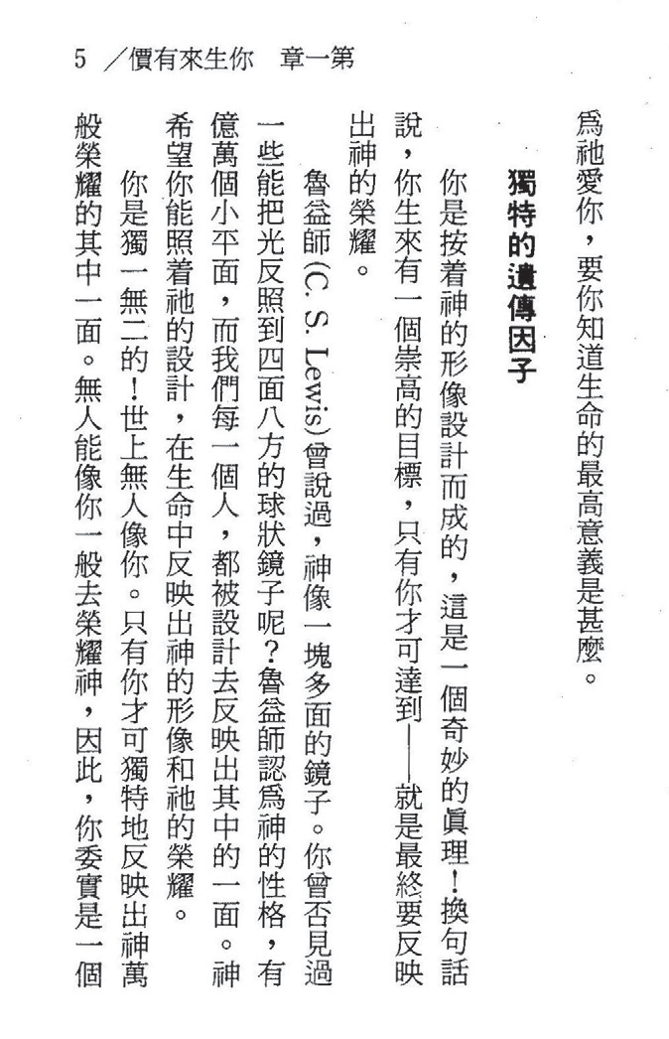

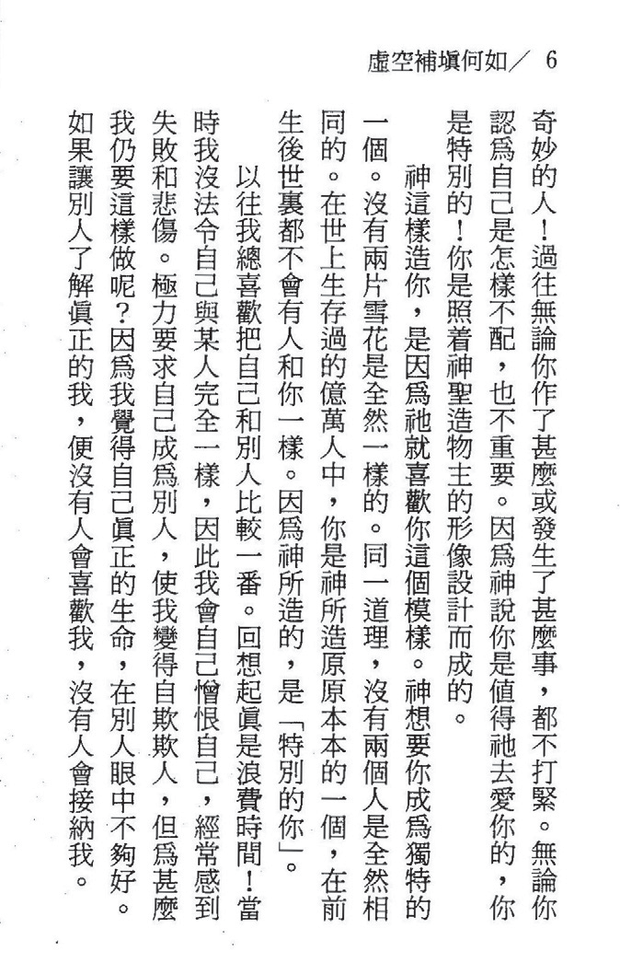

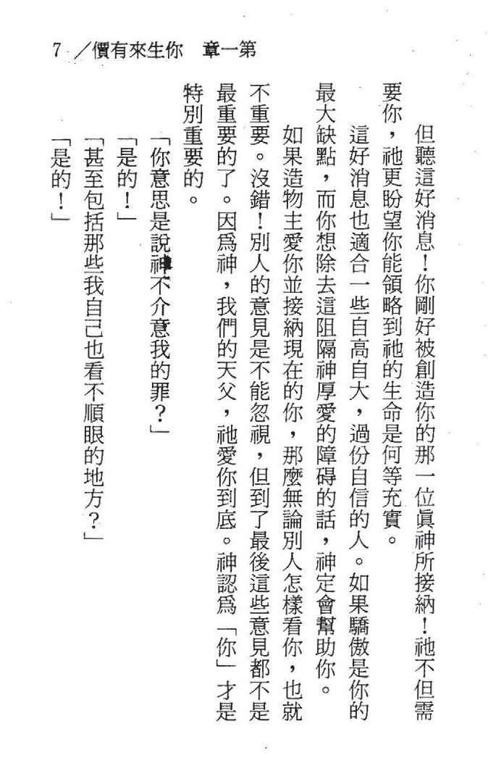

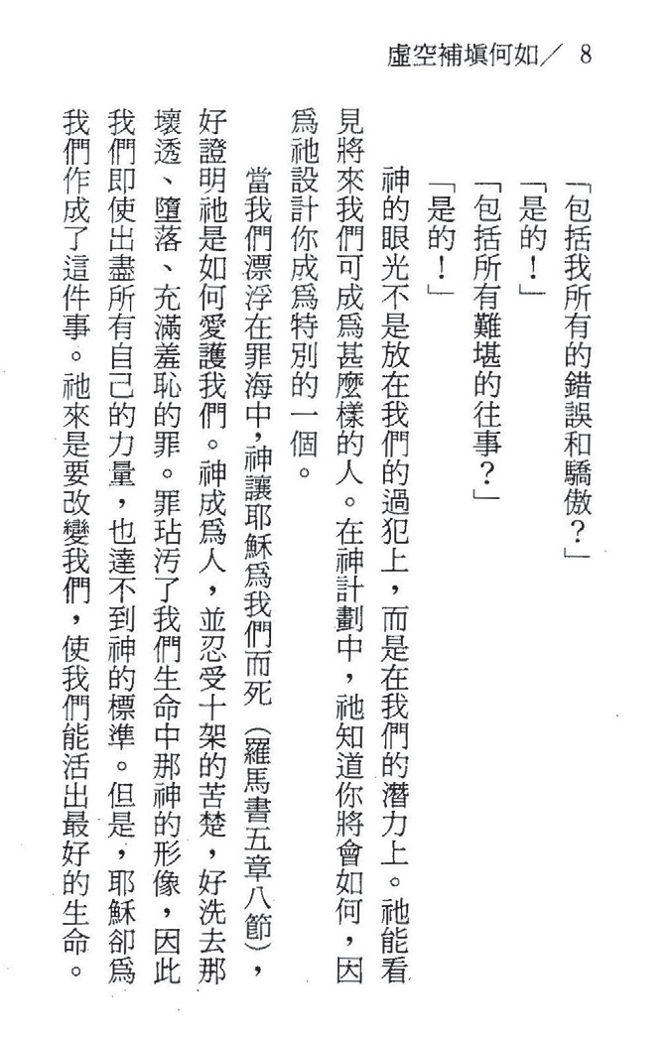

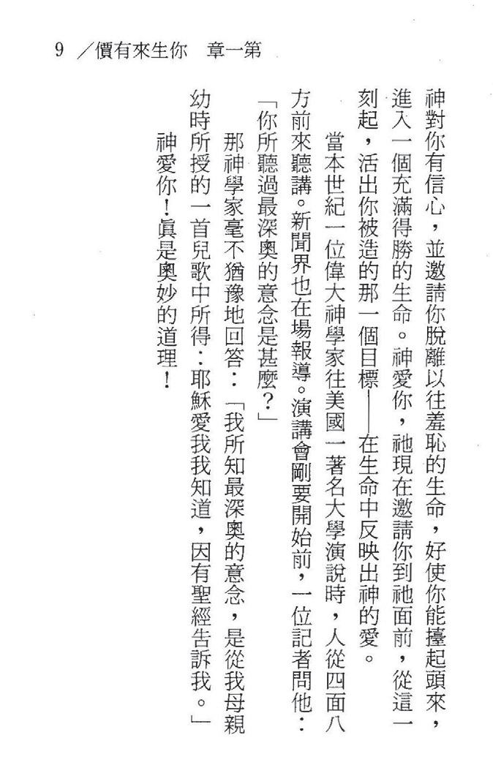



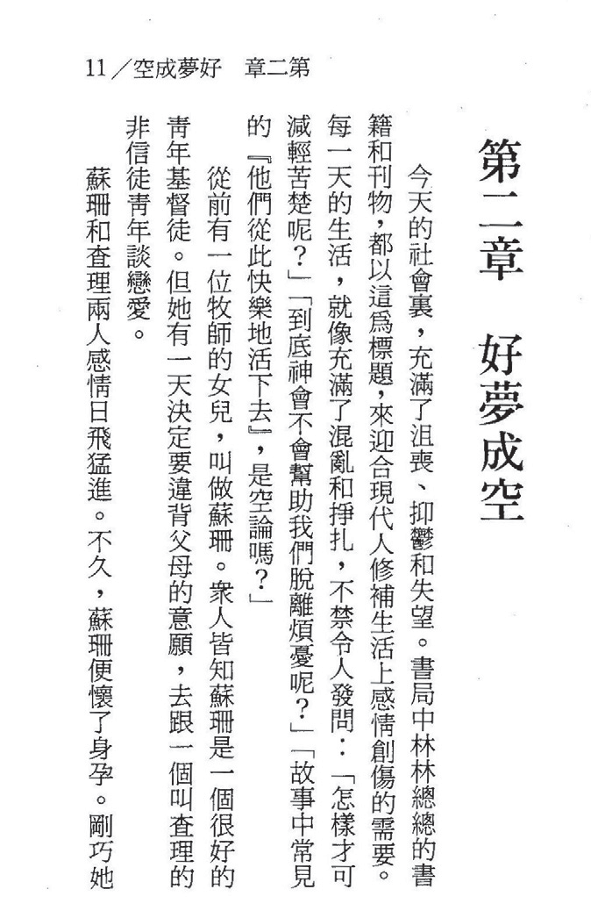

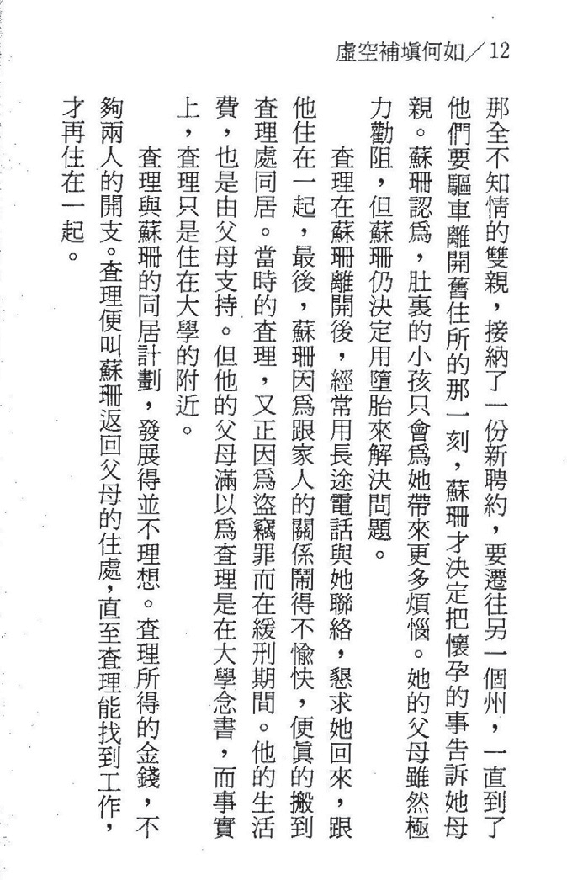

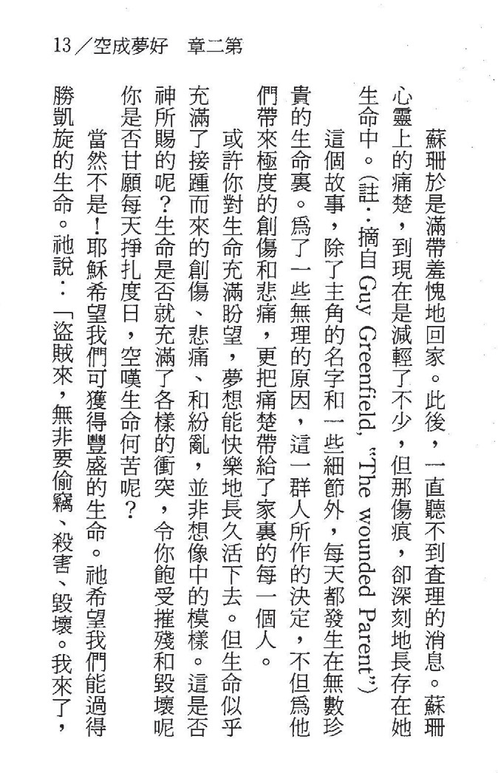

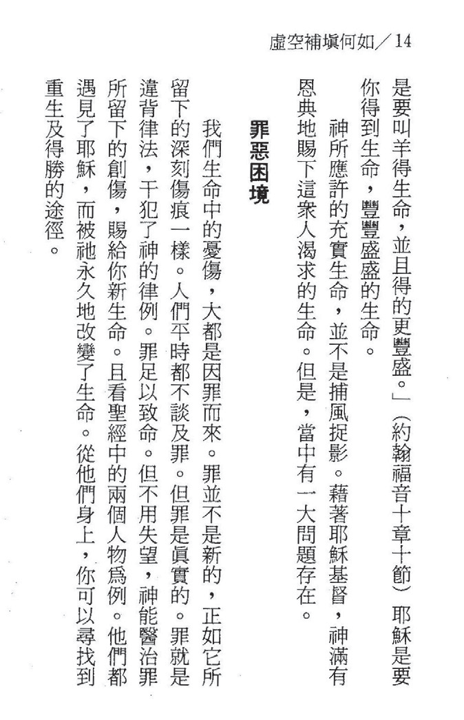

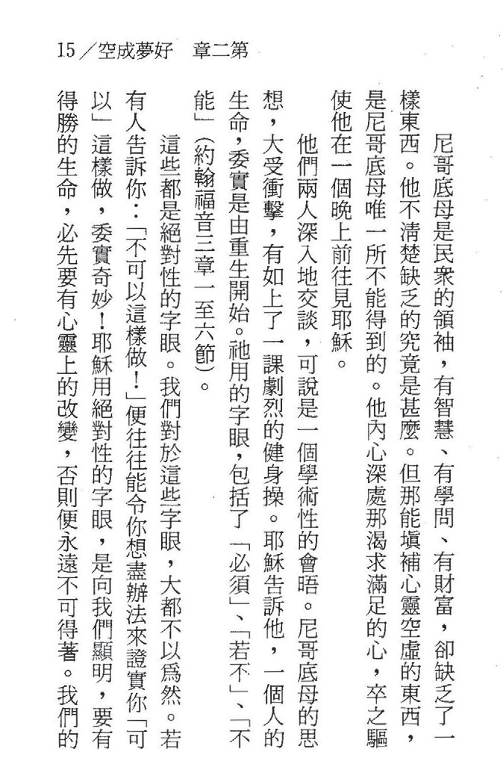

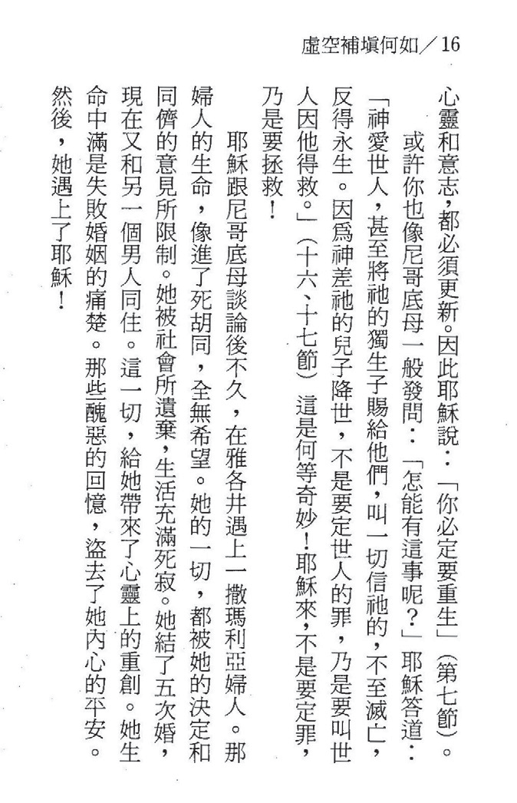

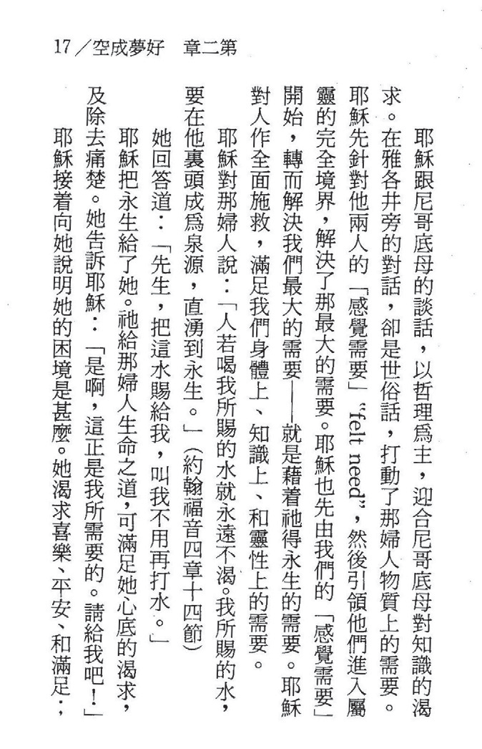

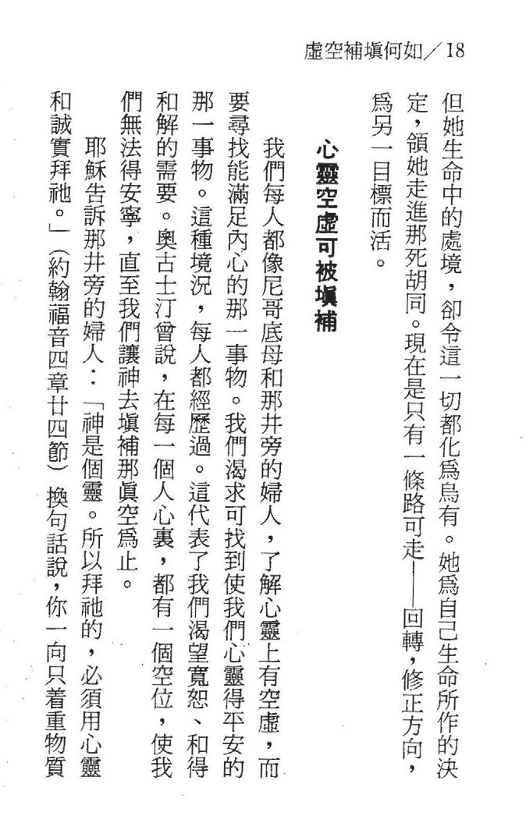

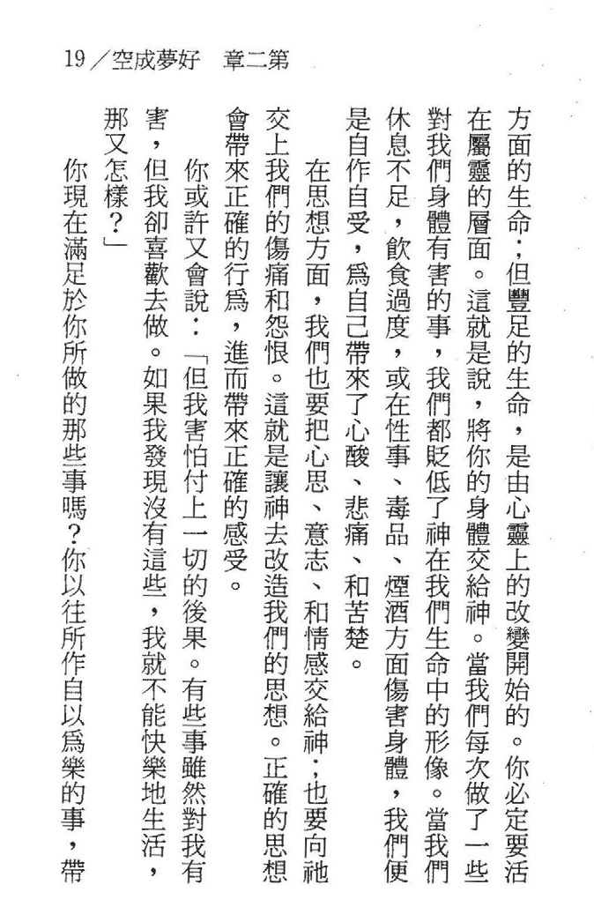

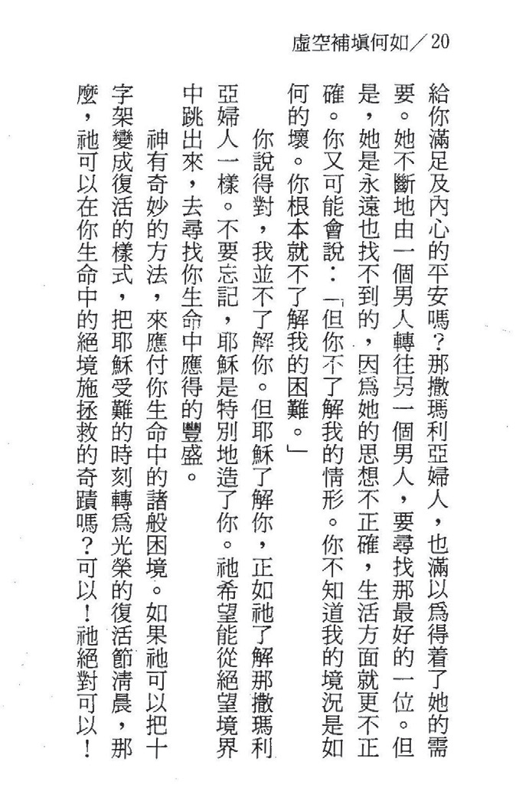

21/1::11l:i<}liJf!); =:m

11'1 f,jj. OJ i¥J
i¥J ·C.'
mm1- •1 UiJdiliJl
<Jltf,jj.' ;il; a¥ 0 OJ if gt J:J m 1!!1 ' {IJ; ):) malt tP- {IJ; ·C.' f!} liil
ti
1* lib {j!I/i {IJ;
{IJ; 0 {i OJI¥1 '
i¥J"'tE :f)(,J;rii%
mltifr '¥1) !IF, {IJ; i¥J 1$

ffii • i! iffi
w.::: '
1S-OJ7
'
(1fp PJ

3(
Jill+ ' it {!);
i"af

i¥JfL if!ftilff,jj. £

B• 'iFl :
·
2jS l dt
3CfD-OJ

<Jltgt-,
£'p'fi
' 3(@1$
& if!ft±l

);) m 0 A J:)
{IJ; it£ {f); "Jj'!li; 0 iJrj
{IJ; *
::!: 11'1 (<;] {IJ; :tE it£
lHi'![t 0
i¥1Mm &11¥1$ n*<Jlt ):) il<J l&J it '¥1J Q1il
r .c., 1¥1
i¥J '
M;--lfp
iJlG 0
¥-.1 {IJ; 'Mil {IJ;

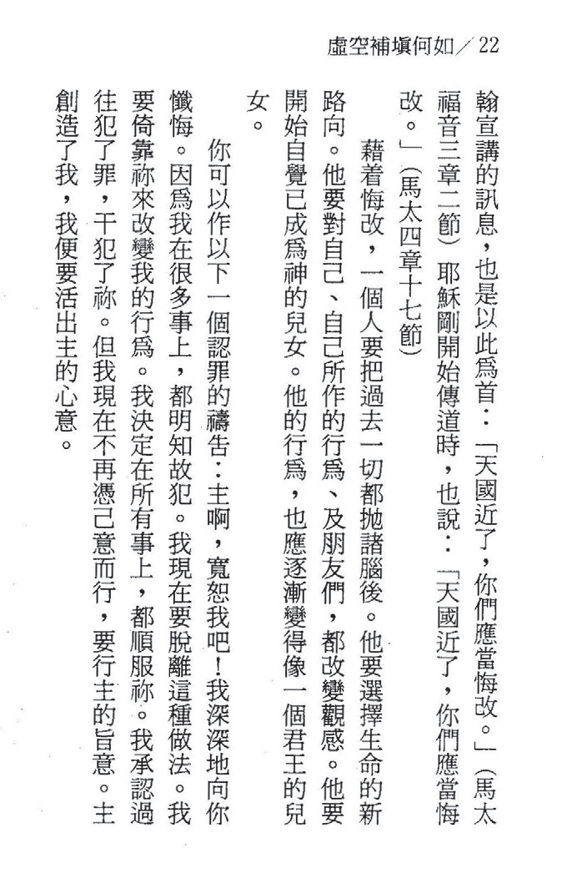

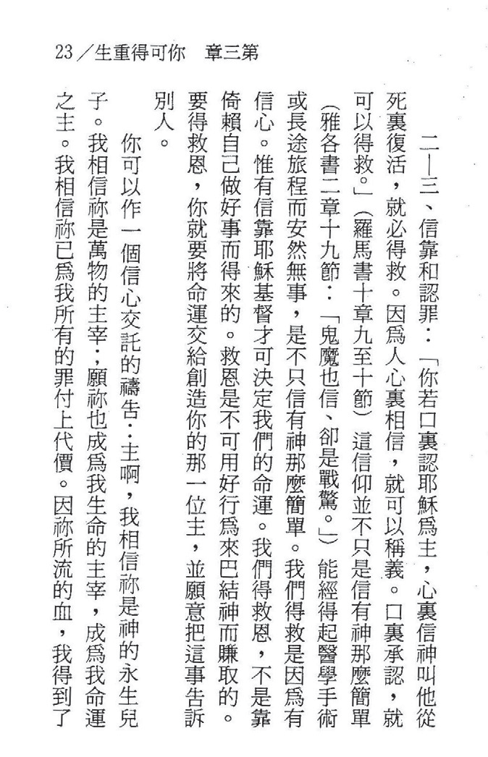

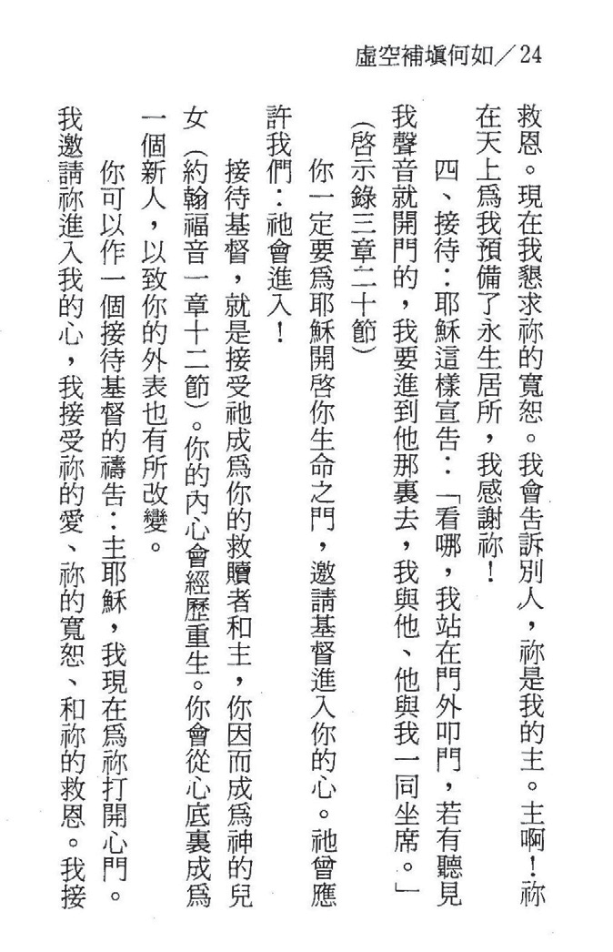

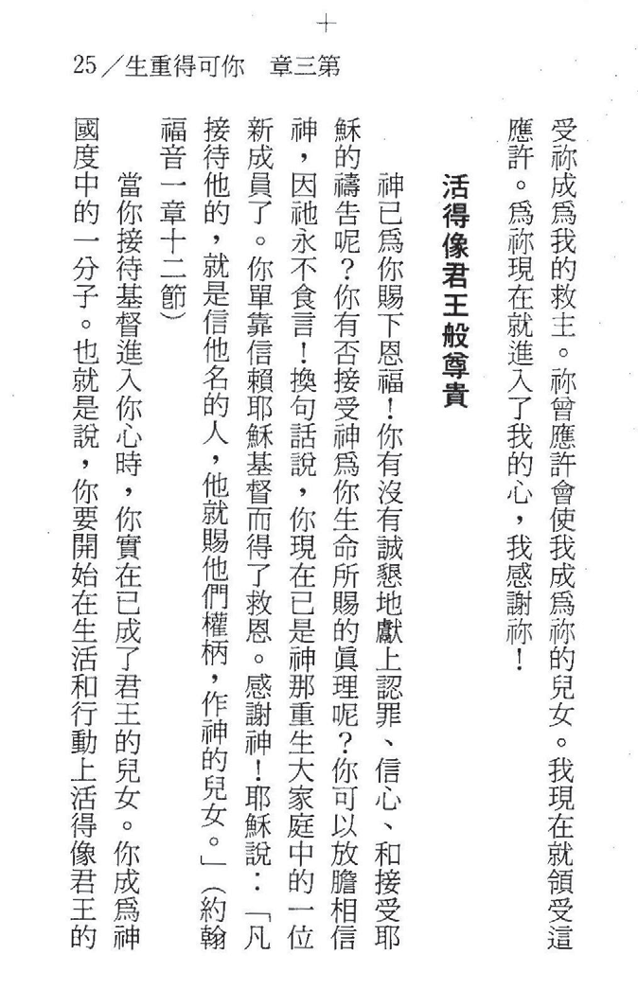

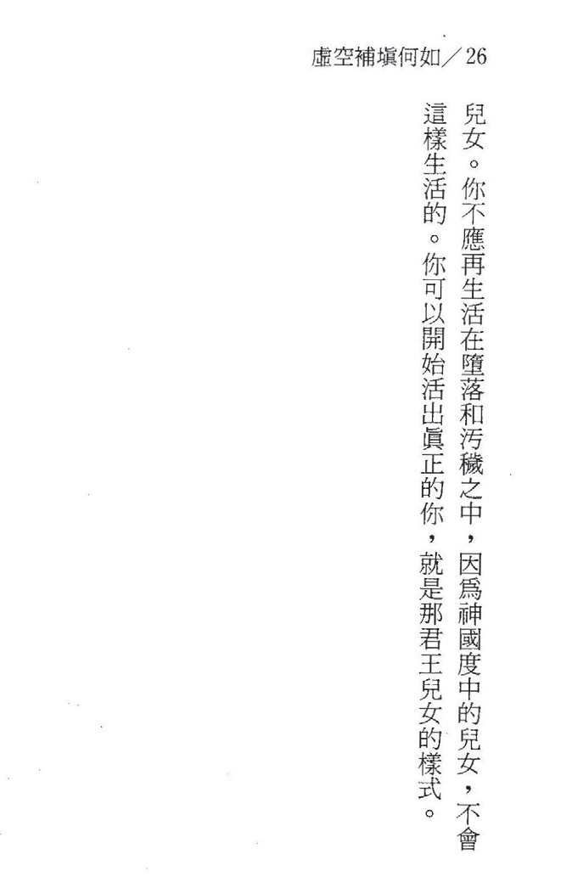

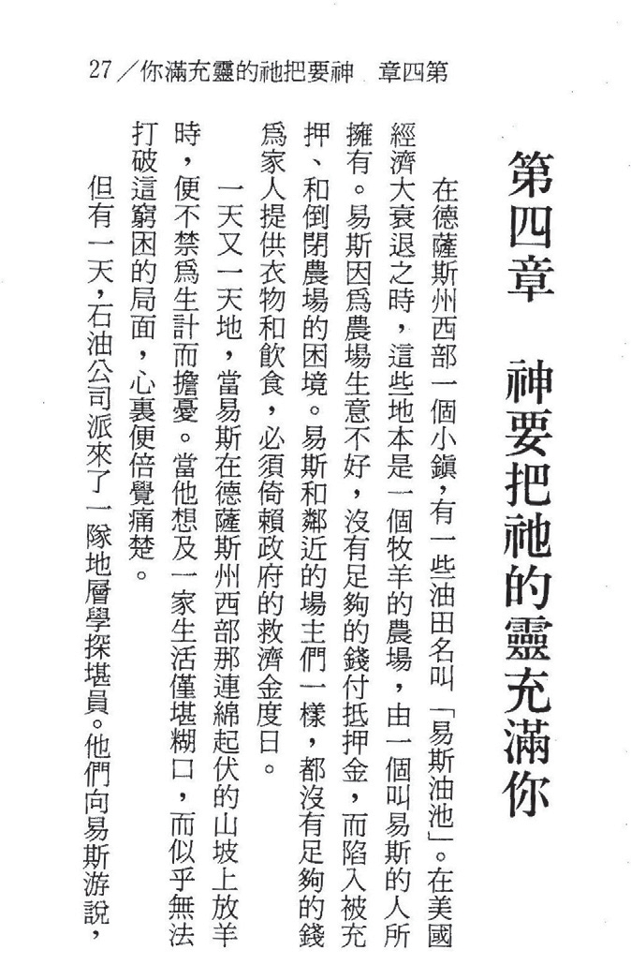

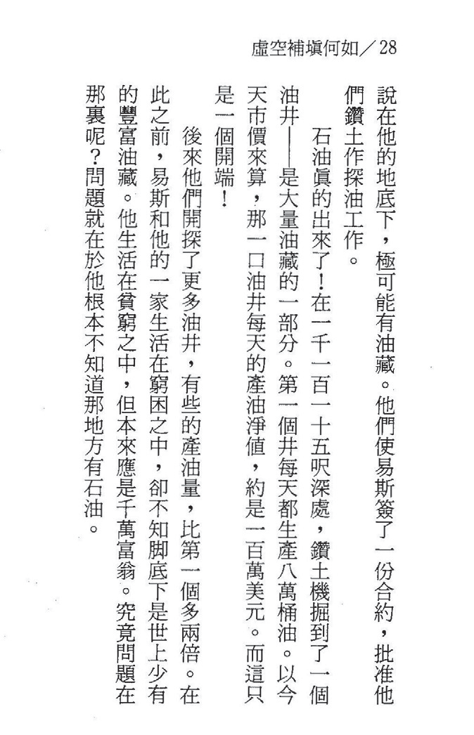

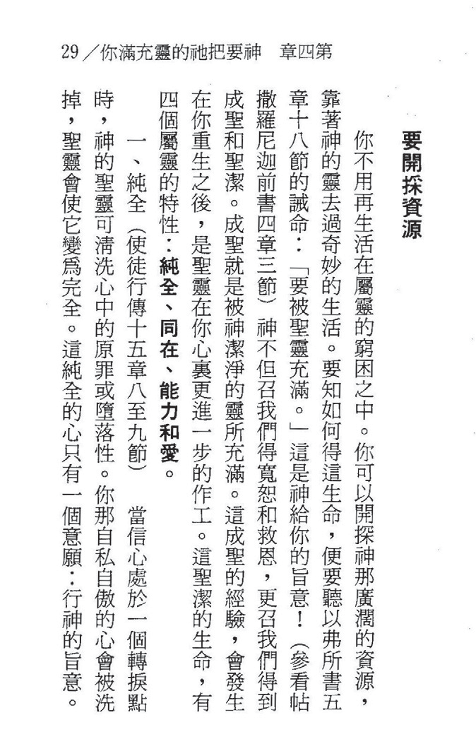

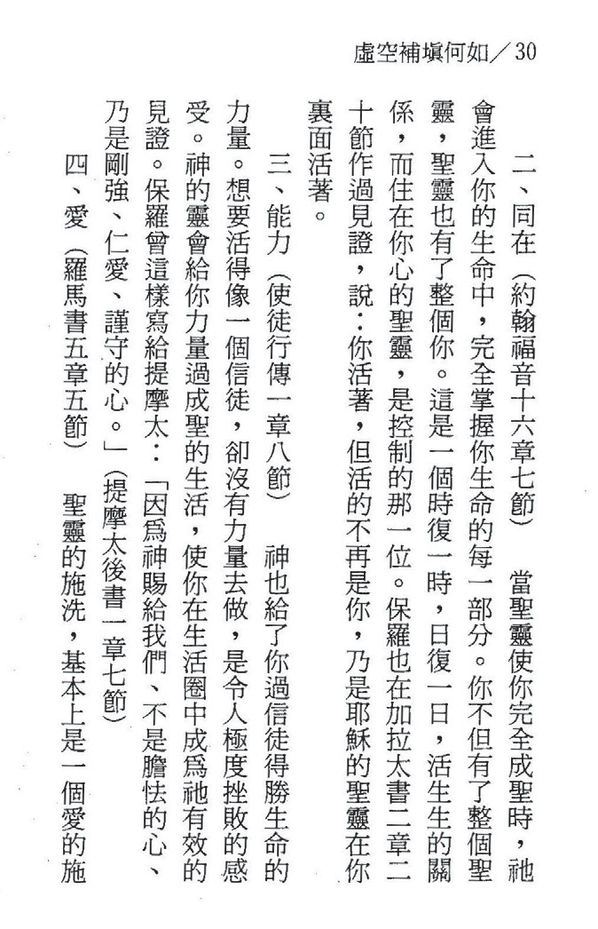

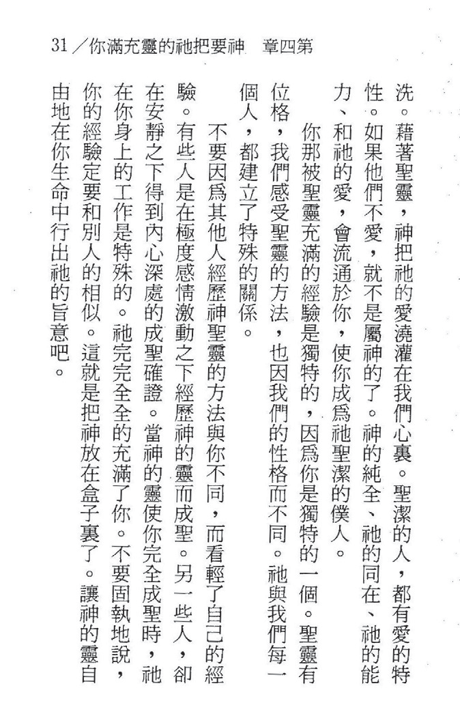

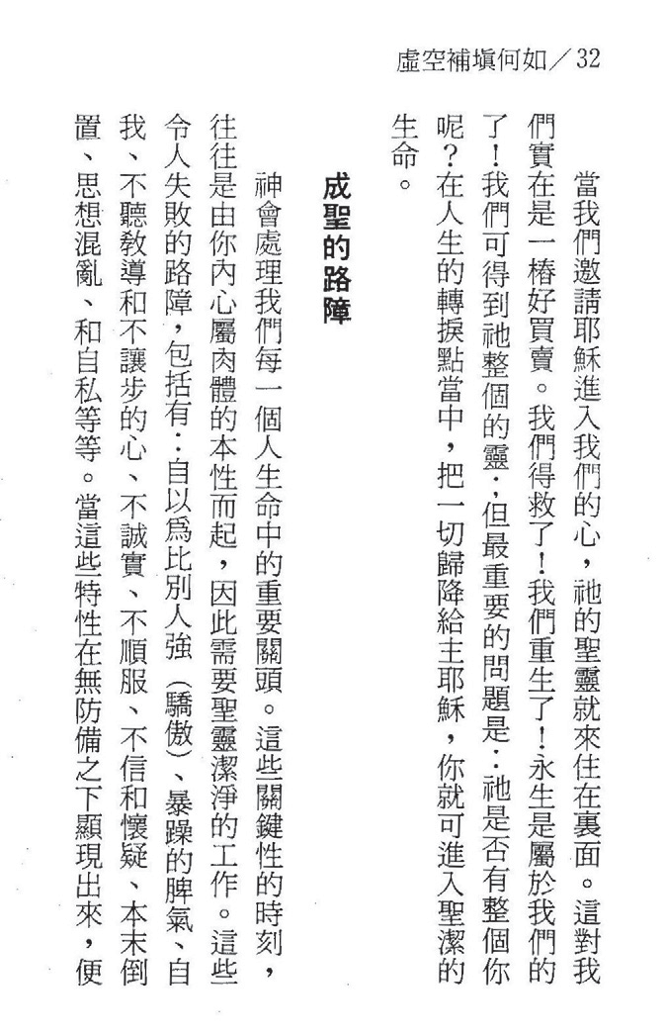

+
33 /l >iili:ft:i!Irt:J I!!ll'l'll!iiilj! '!i!'ll!lm

